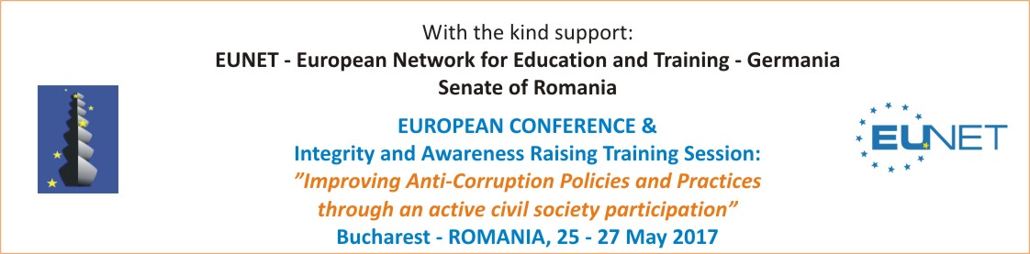

Enrollment Form

Name:

Position:

Institution / Organisation:
Name:
Address:

Contact details: Invoice details:
Phone: | Institution:
Fax: | Registration number:
Mobile: | Fiscal code:
E-mail: | Account:
Web: | Bank:

I want to register to the event | Contribution
Deadline: 4 May 2017 | 235 lei  (or 50 Euro)

Date:

Please send the Enrollment Form to:

